AI3021 - IT IN AGRICULTURAL
UNIT – 1: PRECISION FARMING
1.Explain the concept of precision farming and explain how it contributes to sustainable agricultural practices.
i. Definition of Precision Farming
- Precision Farming is a modern farming method that uses technology like sensors, GPS, GIS, and drones to manage fields accurately.
- It focuses on applying the right input (water, fertilizer, pesticide) at the right place, at the right time, and in the right amount.
- It collects and analyses data about soil, crops, weather, and field conditions to make better farming decisions.
- It aims to increase productivity while reducing waste, cost, and environmental damage.
ii. Key Steps in Precision Farming
- Data Collection
  - Sensors, drones, satellites and soil tests collect information about crop health, soil nutrients, moisture, pests, and weather.
- Data Analysis
  - GIS maps, GPS data, and computer software are used to study the collected data and understand variations in the field.
- Decision-Making
  - Farmers decide exactly what each part of the field needs (water, fertilizer, pesticide).
- Precise Application of Inputs
  - Machines and Variable Rate Technology apply inputs only where required, saving cost and increasing efficiency.
iii. Key Components of Precision Farming
- Ground-based sensors – Measure soil moisture, nutrient content, and crop health.
- Remote sensing and drones – Monitor crop stress, pests, and disease outbreaks.
- GPS and GIS mapping – Divide the field into zones and create soil fertility/ moisture maps.
- Yield Mapping Systems – Collect harvest data to identify high- and low-yielding areas.
- Variable Rate Technology (VRT) – Machines adjust fertilizer/pesticide application according to crop requirements.
- Crop Production Modelling – Predict crop growth and future yields using computer simulations.
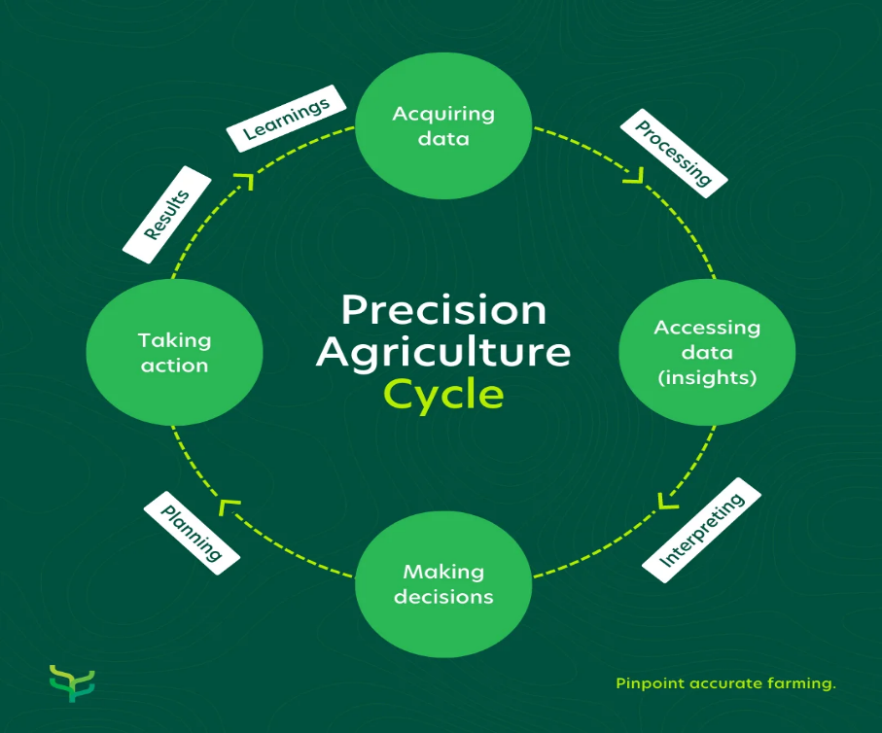
iv. Precision agriculture cycle:

v. How Precision Farming Contributes to Sustainable Agriculture
1. Saves Resources (Water, Fertilizer, Pesticides)
- Water is applied only where soil is dry.
- Fertilizers are given only to areas that lack nutrients.
- This reduces wastage and saves money.
2. Protects the Environment
- Less chemical use means less soil pollution and cleaner groundwater.
- Reduces pesticide drift and chemical runoff.

3. Improves Soil Health
- Balanced nutrient application maintains long-term soil fertility.
- Prevents soil degradation and overuse of chemicals.
4. Reduces Cost and Increases Profit for Farmers
- Farmers spend less on inputs and get higher yields.
- Automation reduces labor cost and fuel consumption.
5. Increases Crop Yield and Food Security
- Real-time monitoring helps detect problems early.
- Timely actions improve crop health and increase production.
- Helps feed the growing population.
6. Supports Climate-Resilient Farming
- Sensors and models can predict drought, pests, and weather changes.
- Helps farmers take preventive action before damage happens.
7. Conserves Water and Energy
- Technologies like drip irrigation and VRI save large amounts of water.
- Reduces energy used for pumping and spraying.
8. Ensures Sustainable Use of Land
- Every part of the land is used optimally.
- Prevents over-farming and maintains long-term productivity.

Examples of Precision Farming in Practice
- India: Use of drones in Punjab for spraying fertilizers in wheat and paddy fields.
- USA: Large farms use GPS-guided tractors for precision seeding and fertilizer application.
- Greenhouse Farming: Sensors monitor CO₂, humidity, and light to maximize plant growth efficiently.

2. Explain the role of GPS and GIS in precision farming. How do these technologies work together to optimize agricultural management?
- Precision farming depends on accurate information about the field, where every part of the field is monitored and managed according to its unique needs.
- Two important technologies used for this purpose are GPS (Global Positioning System) and GIS (Geographic Information System).
- GPS provides accurate location data for fields, machinery, and crop conditions.
- GIS helps in analysing, storing, and visualizing spatial (map-based) agricultural information.
- Together, they help farmers understand what is happening in every part of their field and manage crops more efficiently.

Role of GPS in Precision Farming
GPS is a satellite-based system that gives farmers exact field positions and coordinates. Its applications include:
- Field Mapping
  - GPS marks exact boundaries of fields.
  - Helps in identifying soil variation zones within a farm.
- Guidance for Machinery
  - Tractors and harvesters fitted with GPS follow accurate paths.
  - Reduces overlapping of sowing, spraying, or harvesting → saves time and fuel.
- Variable Rate Application
  - GPS guides equipment to apply fertilizer, seeds, or pesticides only where required.
  - Prevents wastage and over-application.
- Yield Mapping
  - During harvest, GPS helps link yield data to specific field locations.
  - Farmers know which part of the field is more or less productive.
Role of GIS in Precision Farming:
GIS is a computer-based tool that manages spatial and geographical data. It integrates data collected from GPS, sensors, and remote sensing.
- Data Integration
  - Combines soil maps, weather data, crop health data, and yield information.
  - Creates a complete digital picture of the farm.
- Spatial Analysis
  - Identifies problem zones (poor soil, low yield, waterlogging areas).
  - Helps farmers target inputs more effectively.
- Decision Support
  - GIS provides thematic maps for irrigation, fertilizer management, and pest control.
  - Supports long-term planning and sustainable practices.
- Monitoring and Forecasting
  - Tracks crop growth, disease spread, and predicts future yield patterns.
How GPS and GIS Work Together
- GPS collects the exact location of soil samples, crop conditions, pests, and yield during harvesting.
- This GPS data is then fed into GIS, which stores and analyses it to create detailed maps of soil nutrients, moisture, crop health, and yield zones.
- Farmers use these GIS maps to decide where more water, fertilizer, or pesticides are needed.
- GPS then guides the tractors and sprayers to apply these inputs accurately.
- Together, GPS and GIS help reduce wastage, improve crop productivity, and make farm management more efficient.
Example: A GPS device records the exact location of low-yield areas during harvesting. GIS then creates a yield variability map, which helps decide how much fertilizer to apply next season.
Benefits of GPS and GIS in Precision Farming
- Optimized Resource Use – Inputs applied only where necessary.
- Higher Productivity – Better decisions improve yields.
- Cost Savings – Reduced wastage of seeds, fertilizers, and pesticides.
- Environmental Protection – Less chemical runoff and soil degradation.
- Time Efficiency – GPS-guided machinery saves labour and fuel.
3. Describe the principles of remote sensing in precision farming. How can remote sensing technologies be used for crop monitoring and management?
1. Introduction
- Remote sensing is a method of collecting information about the Earth’s surface without touching it, using satellites, drones, and aircraft.
- It allows farmers to observe crop growth, soil moisture, and environmental changes from a distance.
- This helps them easily identify problems like disease, drought, and nutrient deficiency.
- Remote sensing provides timely and large-scale data that is difficult to collect manually.
- In precision farming, remote sensing helps make better decisions about irrigation, fertilizers, pest control, and yield prediction.
2. Principles of Remote Sensing
- Source of Energy (Sunlight): The Sun sends light to the Earth. This light acts as the energy source that enables remote sensing observations.
- Interaction with the Earth’s Surface: When sunlight hits crops, soil, or water, it gets reflected, absorbed, or transmitted.
- Sensor Detection: Sensors mounted on satellites, aircraft, or drones capture the reflected energy. Each sensor records different spectral bands (visible, infrared, thermal).
- Data Transmission & Processing: The captured images are sent to ground stations and processed using software like GIS. The processed images turn into maps showing vegetation health, moisture, and problem areas.
- Interpretation & Application:
Experts and farmers analyze these maps to identify issues like pests, diseases, water stress, or nutrient deficiency. This helps take quick and accurate actions in the field.

3. Components of a Remote Sensing System:
- Energy Source: Usually the Sun, which provides the light needed for sensing.
- Atmosphere: Light passes through the air, and the atmosphere affects how much energy reaches the ground.
- Target: The object being studied—crop, soil, or water.
- Sensor: The device on a drone or satellite that captures the reflected energy.
- Data Processing System: Software that converts raw images into maps and reports.
- End User: Farmers who use this information to make better decisions.

4. Types of Remote Sensing Used in Agriculture (Extended in simple terms)
1. Optical Remote Sensing
Uses visible and infrared light. Helps check plant health, leaf color, and greenness.
Example: NDVI maps show how healthy the plants are.
2. Thermal Remote Sensing
Measures land and crop temperature.
Useful to find areas suffering from water stress or needing irrigation.
3. Microwave / Radar Remote Sensing
Can work even at night or under clouds.
Very useful for soil moisture measurement during rainy seasons.
4. Drone-Based Remote Sensing
Provides very clear images.
Useful for small farms to check pests, weeds, and plant growth.

5. Applications of Remote Sensing in Precision Farming
(a) Crop Health Monitoring
Shows areas where crops are stressed, sick, or lacking nutrients by analyzing light reflection.
(b) Soil Moisture & Irrigation Planning
Finds dry and wet areas so farmers can irrigate only where needed.
(c) Fertilizer Management
Detects nutrient-poor zones and guides farmers to apply fertilizer only there.
(d) Pest & Disease Detection
Changes in plant color or reflectance help identify pest attacks early.
(e) Yield Prediction
Tracks crop growth over the season and estimates final yield.

(f) Weed Mapping & Water Stress Mapping
Shows weed-infested areas and dry patches to guide spraying and irrigation.
(g) Disaster Monitoring
Helps assess crop damage after floods, droughts, or storms for insurance and government support.

6. Benefits of Remote Sensing in Precision Agriculture (Elaborated)
- Detects crop issues early, preventing yield loss.
- Saves water, fertilizer, and chemicals by using them only where needed.
- Improves crop productivity through timely actions.
- Reduces labor and time, as field visits become less necessary.
- Protects the environment by preventing chemical overuse.
- Supports decision-making with accurate maps and data.

7. Limitations (Extended a little)
- High cost of drones, sensors, and software.
- Requires technical knowledge to understand images.
- Cloud cover affects optical sensing, especially during monsoons.
- Large data processing needs strong computers and skills.
- Poor internet access in rural areas limits usage.

8. Conclusion:
Remote sensing is a powerful tool that helps farmers monitor crops, soil, and water without physical contact.
It makes farming smarter by giving accurate information for decisions on irrigation, fertilizer, pest control, and yield prediction.
Combined with GPS, GIS, and modern technology, it supports sustainable, efficient, and productive agriculture.

4. What are yield mapping systems, and how do they contribute to precision agriculture? Discuss the advantages and limitations of using yield mapping in modern farming.
1. Yield Mapping System:
- Yield mapping is a system that measures how much crop is harvested at every location in the field.
- It uses sensors and GPS on harvesting machines to record yield, moisture, and position in real time.
- The collected data is converted into color-coded maps showing high-yield and low-yield areas.
- These maps help farmers understand field variability and manage inputs more accurately.

2. Components of a Yield Mapping System:
- GPS Receiver: Determines the exact location of the harvester in the field.
- Yield Sensor: Measures the mass or flow of harvested grain
- Moisture Sensor: Records the moisture level of the harvested crop.
- Data Logger / Computer: Collects and stores yield and location data for processing.
- Mapping Software: Converts raw data into yield maps and charts for analysis.

3. Working of Yield Mapping System (Step-by-Step)
- During harvesting, the combine harvester cuts and collects the crop.
- Yield monitor measures grain flow rate and amount of crop harvested.
- Moisture sensor checks the moisture content of the harvested crop.
- GPS marks the exact position where the crop was harvested.
- Data is stored and later sent to a computer.
- Software creates a color-coded yield map showing yield variations across the entire field.
Example: Green = High yield, Yellow = Medium yield, Red = Low yield

4. Contribution of Yield Mapping to Precision Agriculture:
- Identifies Field Variability: Shows which parts of the field perform well and which areas need improvement.
- Helps Create Management Zones: Farmers divide the field into zones and treat each zone differently (more fertilizer, less water, etc.).
- Improves Fertilizer and Water Efficiency: Poor-yield zones can be corrected with targeted fertilizers, improving overall yield.
- Supports Variable Rate Technology (VRT): Inputs like seeds, fertilizers, and pesticides are applied based on yield data.
- Detects Long-Term Problems: Consistent low-yield areas may indicate soil issues, pests, drainage problems, or erosion.
- Better Farm Planning: Helps farmers evaluate what worked and what failed in previous seasons.
5. Advantages of Yield Mapping
- Better Decision Making: Helps farmers plan fertilizers, irrigation, and pesticide use based on actual field performance.
- Higher Productivity: Weak areas can be corrected, improving total yield.
- Cost Savings: Inputs are applied only where needed → reduces fertilizer and chemical costs.
- Supports Smart Technologies: Works with GPS, GIS, soil maps, and VRT to improve precision.
6. Limitations of Yield Mapping
- High Cost: Equipment like yield monitors and GPS systems are expensive.
- Technical Knowledge Required: Farmers must understand calibration, software, and map interpretation.
- Large Data Handling: Requires strong computer systems and storage.
- Not Effective in Very Small Fields: Small fields may show little meaningful variation.
7. Future Scope of Yield Mapping:
- Integration of IoT and AI to automatically adjust inputs in real-time.
- Use of drones and satellite imaging for more detailed yield estimation.
- Cloud-based yield data sharing for regional agricultural analysis.
5. Explain crop production modeling in precision agriculture. How does crop modeling help farmers predict yields, manage risks, and improve resource management?
1. Introduction
- Crop growth depends on many factors like soil quality, rainfall, temperature, fertilizers, and pest attacks.
- Because all these factors constantly change, it becomes difficult for farmers to correctly predict crop growth and final yield.
- Crop Production Modeling solves this problem by using mathematical formulas, computer simulations, and weather–soil data to predict how a crop will grow and how much it will produce.
- Instead of depending only on experience, farmers can make scientific and data-based decisions.

2. Concept of Crop Production Modeling:
- Crop models simulate the entire life cycle of a plant—from seed to harvest.
They consider climate, soil type, water levels, fertilizers, and crop management practices.
- Models use real data such as field measurements, weather conditions, and soil information.
- Based on this data, models predict important things like crop growth, water needs, nutrient needs, and final yield.
- Examples of crop models: DSSAT (Decision Support System for Agrotechnology Transfer), APSIM (Agricultural Production Systems Simulator), WOFOST (Wageningen Crop Growth Model)
These models help farmers understand how crops will perform under different conditions.

3. Components of Crop Production Modeling
- Input Data: Soil type, fertility levels, irrigation schedule, fertilizer application, climate data.
- Simulation Engine: Mathematical formulas for photosynthesis, respiration, water use, and nutrient uptake.
- Output Data: Crop growth stages, expected yield, resource use efficiency, and risk analysis.

4. How Crop Modeling Helps Farmers (Elaborated & Simple)
1. Predicting Yields
- Models calculate expected yield by studying weather, soil, and crop management.
- Farmers know the harvest quantity before harvesting.
- Helps plan storage, marketing, and selling strategies.
Example:
If the model predicts a low yield, farmers can plan to buy food from the market or switch crops next season.

2. Managing Risks
- Models show how drought, pests, diseases, or climate change affect the crop.
- Farmers can take preventive steps early.
Examples:
- If the model predicts drought → farmer increases irrigation or selects drought-tolerant seeds.
- If delayed monsoon is expected → farmer shifts to short-duration crops.

3. Improving Resource Management
- Models tell exactly when and how much water, fertilizer, or pesticide is needed.
- Helps avoid wastage and reduces cost.
Example:
Model recommends that irrigation can be reduced to 70% without affecting yield → saves water.

4. Decision Support for Precision Farming
- Helps select best crop varieties for local climate.
- Guides planting dates, fertilizer schedule, and harvest timing.
- Helps plan crop rotation for long-term soil health.

5. Benefits of Crop Production Modeling in Precision Agriculture
- Higher Productivity
Optimizes crop management practices for better yield.
- Cost Reduction
Avoids unnecessary fertilizer, pesticide, and water use.
- Sustainable Farming
Protects soil, saves water, and reduces chemical pollution.
- Climate-Smart Agriculture
Helps farmers adapt to climate change by predicting extreme conditions.
- Useful for Government and Researchers
Helps plan food security, storage, and national agricultural policies.

6. Conclusion
Crop production modeling is a powerful tool in precision agriculture.
It uses scientific data and computer simulations to predict crop growth, estimate yield, manage risks, and optimize resource use.
This leads to higher productivity, lower costs, and sustainable farming.
In today’s world of climate uncertainty and limited resources, crop modeling is essential for smart, efficient, and future-ready agriculture.

